**Tribhuvan University**

SIDDHANATH SCIENCE CAMPUS

Institute of Science and Technology

Mahendranagar, Kanchanpur

**INTERNSHIP REPORT  
ON  
HOME HEALTH CARE SYSTEM**

**SUBMITTED TO:**SIDDHANATH SCIENCE CAMPUS  
DEPARTMENT OF COMPUTER SCIENCE AND IT  
Mahendranagar, Kanchanpur

**SUBMITTED BY:**

Yogendra Dhami (11310/073)

November, 2021



**Student’s Declaration**

I hereby declare the internship report entitled **“home health care sytem”** submitted to the office of dean, Faculty of Science and Technology, Tribhuwan University, is my internship done in partial fulfillment of the requirements for the Bachelor of Science in Computer Science and Information Technology under the supervision and guidance of **Mr. Rajendra Prasad Joshi** as a supervisor and **Mr. Amit kumar Joshi** senior developer of **Beginning of Innovative Generation.** as a mentor.

…………………………….

**Mr. Yogendra Dhami**

**Symbol No.:**

11310/073****

**Mentor’s Recommendation**

I hereby recommend that this internship report prepared under my supervision by **Yogendra Dhami** entitled **“home health care system”** be processed for evaluation as fulfilling in partial requirements for the degree of Bachelor of Science in Computer Science and Information Technology.

………………………..

**Mr. Amit Kumar Joshi**

Senior Developer

Beginning of innovative generation .

(Internship Mentor)

**Tribhuwan University**

SIDDHANATH SCIENCE CAMPUS

Institute of Science and Technology

Mahendranagar, Kanchanpur



**SUPERVISOR’S RECOMMENDATION**

I hereby recommend that this internship report prepared under my supervision by Yogendra Dhami entitled “ **home health care sysyem**” is accepted as fulfilling in partial requirements for the degree of Bachelor of Science in Computer Science and Information Technology. In my best knowledge this is an original work in Computer Science.

**......................................................**

**Mr. Rajendra Prasad Joshi**

Supervisor

Department of CSIT

Siddhanath Science Campus

Mahendranagar, Kanchanpur

**Tribhuwan University**

SIDDHANATH SCIENCE CAMPUS

Institute of Science and Technology

Mahendranagar, Kanchanpur



**LETTER OF APPROVAL**

This is certify that this project prepared by Yogendra Dhami entitled “**home health care system**” in partial fulfillment of the requirements for the degree of B.Sc. in Computer Science and Information Technology has been well studied. In our opinion, it is satisfactory in the scope and quality as a project for the required degree.

…………………………….. ……………………………

**(Supervisor) (HOD)**

**Rajendra Prasad Joshi Mr. Keshav Datta Bhatta**

Faculty, Department of CSIT Faculty, Department of CSIT Siddhanath Science Campus Siddhanath Science campus

Mahendranagar, Kanchanpur Mahendranagar, Kanchanpur

……………………………… ……………………………

**(External Examiner) (Internal Examiner)**

# ACKNOWLEDGEMENT

I would like to express my sincere gratitude to my supervisor **MR. RAJENDRA PRASAD JOSHI**, lecturer of Department of Computer Science for his incredible support and guidelines during the entire internship project execution.

I would also like to thank **Mr. KESHAV DATTA BHATTA (HOD),** department of  
Computer Science for his constant suggestions and guidance. His painstaking  
encouragements boosted morale for the completion of this project.

I would also like to appreciate **Mr. Amit Kumar Joshi**. Senior Developer of the **Beginning of innovative generation.,** for his valuable guidance throughout of the project. Without his guidance, the project would not have been successful.

Also, we would like to say thanks hearty to our honorable campus chief **Dr. GAJRAM DAMAI** and our respected teachers **Mr. UPENDRA JOSHI** and **Mr. PRAKASH DATTA BHATTA** and **Mr. DILLI RAJ JOSHI**.

We also thanks all those who have supported us throughout the entire duration of our project.

Finally, thanks to teaching and non-teaching staff members of the SIDDHANATH SCIENCE CAMPUS and all our friends for their honest opinions and suggestions throughout the course of our project.

# ABSTRACT

Home health care is a system of care provided by skilled practitioners to patients in their homes under the direction of a physician. Home health care services include nursing care; physical, occupational, and speech-language therapy; and medical social services.[1](https://www.ncbi.nlm.nih.gov/books/NBK2631/) The goals of home health care services are to help individuals to improve function and live with greater independence; to promote the client’s optimal level of well-being; and to assist the patient to remain at home, avoiding hospitalization or admission to long-term care institutions. Physicians may refer patients for home health care services, or the services may be requested by family members or patients.

The report is about call those health checkup persons who provide health check up services at home. Health check up at home system plays important roles in taking good care of peoples at their home only which makes easier for peoples to good care of themselves. In current time peoples are so busy to make there carrier because of this peoples are unable to take good care of there health to resolve this problem we started a service in which we give a health related all services at their home at any time in minimum cost as per others. Now a days people are interested to take services at their own place instead of visiting hospitals and standing in big queue in the hospital

The system is developed using Php with laravel framework, and SQL as the backend database. The system is developed and implemented and the result is satisfactory. In the future this system will be enhanced based on further requirements.

# LIST OF ABBREVIATION

API : Application Programming Interface

CGI : Common Gateway Interface

CLI : Command-Line Interface

CSS : Cascading Style Sheet

DBMS : Database Management System

DFD : Dataflow Diagram

ERD : Entity Relationship Diagram

GB : Giga Byte

HTML : Hypertext Markup Language

IP : Internet Protocol

MB : Mega Byte

MD5 : Message Digest 5

MVC : Model View Controller

NIC : Network Interface Card

PYTHON : Hypertext Query Language

RAM : Random Access Memory

SDLC : System Development Life Cycle

SQL : Structure Query Language

TCP : Transmission Control Protocol

UI : User Interface

URL : Universal Resource Locator

TTS : Text-to-Speech

STT : Speech-to-Text

IVR : Interactive Voice Response

ASR : Automatic Speech Recognition

W3C : World Wide Web Consortium

# LIST OF FIGURES

Figure 4.1: Gantt chart…… ………………………………………………………..12

Figure 4.2: Use Case Diagram for User…………………………………………....15

Fig 5.1: Context diagram…………………………………………………………….22

Fig 5.2: Level 1 DFD….……………………………………………………………..23

Fig 5.3: Level 2 DFD….……………………………………………………………. 24

Fig 5.4: Class Diagram………………………………………………………............25

Fig 5.5: ER Diagram……………………………………….………………………..26

TABLE OF CONTENTS

ACKNOWLEDGEMENT vi

ABSTRACT vii

LIST OF ABBREVIATION viii

LIST OF FIGURES ix

CHAPTER 1 1

INTRODUCTION 1

1.1 Introduction 1

1.2 Problem Definition 1

1.3 Objectives 2

1.4 Background 2

1.5 Brief Introduction of Organization 3

About Organization 3

Services Offered by Organization 3

Organization Hierarchy 4

Contact Information 5

1.6 Internship Details 5

1.7 Internship Placement Details 6

Organization Selection 6

Placement 6

Roles and Responsibilities 6

Details of the work done 8

1.8 Motivation 8

1.9 Report Organization 9

CHAPTER 2 10

LITERATURE REVIEW AND METHODOLOGY 10

2.1 Introduction 10

2.2 Existing System 10

2.3 Proposed System 11

2.4 Methodology 12

CHAPTER 3 13

SYSTEM ANALYSIS AND DESIGN 13

3.1 System Analysis 13

3.1.1 Feasibility Analysis 13

3.1.2 Requirements Analysis 17

3.1.2.1 Functional Requirements 17

3.1.2.2 Non Functional Requirements 19

3.1.3 Data Model Requirements 20

3.2 System Design 22

3.2.1 Context Diagram 22

3.2.2 Level – 1 Dataflow Diagram 22

3.2.3 Level – 2 Dataflow Diagram 23

CHAPTER 4 25

IMPLEMENTATION 25

4.1 Introduction 25

4.2 Front End Tools 25

4.3 Back End Tools 27

CHAPTER 5 29

TESTING 29

5.1 Introduction to Testing 29

5.1.1 Unit Testing 29

5.1.2 Integration Testing 30

5.2 Result Analysis 30

5.2.1 Validation 31

CHAPTER 6 32

CONCLUSION AND FUTURE WORK 32

6.1 Conclusion 32

6.2 Future Scope 32

REFERENCES 33

# CHAPTER 1

# INTRODUCTION

## Introduction

The internship is done as a partial fulfillment of requirements of the Bachelor’s degree in Computer Science and Information Technology under Tribhuvan University. The internship is assigned six credit hours (minimum of ten weeks or 180 hours long) as a part of the course requirement.

During the internship period, I have involved in a software development company named as Beginning of Innovative Generation. During this internship period I have involved in web application program design and development. I have mainly spent my 3 months period in developing a Personal Finance Management System.

A **home health care system** is a one kind of digital way to provide health related services to sick peoples that help to give services to the peoples. It is designed to help patients to routinely check up them at their place only and also they don’t need to visit hospital small health related problems and also they can buy their medicine by placing order on this site and there is both kinds of payment system thorough online and cash. Since, this system is web based, user can easily access any time and any palaces. User interface of the health service management system is very simple and attractive so it is easy to understand and the best way to save time and get best service at their own place.

## Problem Definition

People used to go hospital for their small problems and also to inject medicine to buy medicine and to consult with the doctor about their problems is very time and money consuming everytime. But now we are providing all services to their own place only as per as the peoples needs. Maintaining availability of all services is the most challenging part our services. As a patient we face many difficulties in our daily life. Health is the most important thing in our life we keep on track all the health related problems at any time we want then we can be overcome this problem by taking help of this service. Most of the people cannot take care of their health because of their busy schedule but now with the help of this site people can take care of their health easiy.

## Objectives

Our goal is to give most of the health related services at their own place where patient don’t need to wait in the queue for small health related issues in the hospital.

* To provide a all the daily routine services such as dressing the wounds inject medicine send the blood sample urine and other samples to the labs etc.
* To save money and time of the patients we provide the services at any place that patient required.
* To manage personal health related issues.
* To provide authentication services to secure log in and store data.
* To review the reports daily, weekly, monthly or yearly.
* To visualize incomes and expenses.

## Background

People a wants their healthy life but every time they are unable to take care of their selves and also due to the busy life they feel to time consuming to go hospital stand in the queue to meet with the doctor. Now a days people do not go hospitals until they get serious health problems due to their busy schedule. So to overcome such problems like go to hospitals for small checkups like urine test, blood test, to inject medicine, counseling with doctors and for other such small problems we brought a service which gives most of the health related services to their homes or work places before they get serious illnesses. Peoples do not worry about their problems if they run with us, we are providing most of the services at the door only. Research and analysis of lot people's lifestyle and interest we found they are willing to use such a system or application to make their life easier to take care of their health and their beloved once and family members. Motivation of developing this application comes from helping people to make their life easier.

## Brief Introduction of Organization

### About Organization

Beginning of Innovative Generation is a national company based on Mahendranagar. It is a company that can cater to every skill requirement, creating flawless digital solutions across both web and mobile platforms. It is the company that is focused on to provide clients with the stable system, steady and available on-line with minimum downtime.

Beginning of Innovative Generation is dedicated towards achieving excellence in the IT sector. Since its establishment various websites and mobile application has been created under its pioneer ship. Beginning of Innovative Generation mainly develops and deploys web application whose app is currently being running in Ecommerce sectors and many fields. Beginning of Innovative Generation has a native android developer team dedicated for the development of mobile application and web page developer for development of web pages and web applications. The team consists of highly qualified and skilled software engineers continuously working for the development of highly specified products.

### Services Offered by Organization

The key rationale that Beginning of Innovative Generation follows is that it encourages well defined project structures and methodologies to design and develop each product and service offering that meets the requirements. The company also keeps its team of technical staffs’ side by side with the latest technology trends. These trends are generally the ones that shape the dynamics of IT and IT enabled solutions market.

Beginning of Innovative Generation also follows another rationale customer centric approach in the products development and service delivery. This approach drives the company towards strategic orientation to offer specialized and cost -effective technology services according to the clients’ requirements.

By following these rationales, Beginning of Innovative Generation provide following services:

* Digital Marketing
* Mobile Application Development
* Web Development
* Search Engine Optimization

### Organization Hierarchy

The organization structure or form of an organization has evolved in order to perform the various roles of the organization and also to provide the services efficiently and effectively. Organizations are usually organized according to the functions they perform to the extent possible so that the company can run smoothly. Beginning of Innovative Generation also has functional organization structure. The structure of Beginning of Innovative Generation is such that it facilitates all the functions carried out by the whole organization. The company has many departments to facilitate the business process that have good co-ordination amongst each other. The organization has a line of authority that flows from top to the bottom of the organizational hierarchy however the flow of information in Beginning of Innovative Generation is as follows:

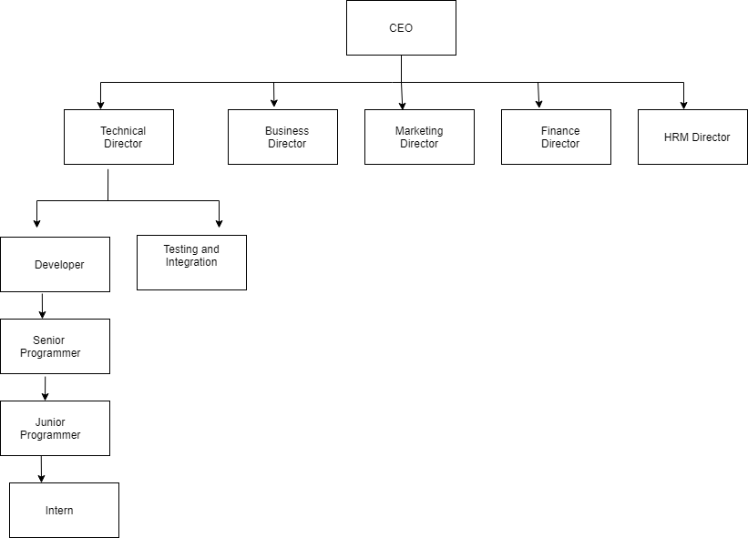

Figure 1.1 Organization Hierarchy

### Contact Information

Name of organization: Beginning Of Innovative Generation

Address: Mahendranagar, Kanchanpur

Telephone: +977- 9864832233

Email: [Gibmnr@gmail.com.np](mailto:Gibmnr@gmail.com.np)

Opening Hours: 10.00 AM – 5.00 PM

## Internship Details

The internship was done at the Zenlab Pvt. Ltd., New Road, Kathmandu under the mentorship of Mr. Amit Kumar Joshi senior developer of the organization. The detail regarding internship is mentioned below:

Organization: Beginning Of Innovative Generation

Address: Mahendranagar, Kanchanpur

Mentor: Mr. Amit Kumar Joshi

Mentor’s Designation: IT Department

Mentor’s Position: Senior Developer

Intern: Yogendra Dhami

Interned as: Web Designing (Frontend) and Web Development (Backend)

Intern Duration: 3 Months

Office Hours: 10.00 AM – 5.00 PM

Working Days: 5 Days per Week (Sunday-Friday)

## Internship Placement Details

The internship is done as a partial fulfillment of requirements of the Bachelor’s degree in Computer Science and Information Technology under Tribhuvan University. The internship is assigned six credit hours (minimum of ten weeks or 180 hours long) as a part of course requirement. The organization followed a systematic process for selection. First of all, the organization carried out an interview which was followed with a programming task to test the candidate’s adaptability to new problems.

### Organization Selection

Among the various criteria and sectors provided to us in internship prerequisite statement, web application design and development was chosen. Various organization were short listed and approached out of which the organization with the best worthwhile offer and environment was selected.

The course of study allows us to acquire knowledge on various aspects of Information Technology. This course provides a mix of information technology which helps the student not only gain the technical expertise and familiarize with skills required in an organization. It gives an opportunity for a good exposure to the various knowledge and expertise learnt throughout the course.

Various organizations had been short listed and approached out of which Beginning of Innovative Generation was chosen, because of its best worthwhile offer and environment; mainly the youth driven and innovation charged influence. Beginning of Innovative Generation has offered many opportunities and infrastructure required in order to understand the technical aspects of a real-world scenario.

### Placement

During the internship tenure, author was provided with simple and comfortable work space at the organization. A dedicated mentor was also assigned to the author to ensure that the project runs smoothly and stays focused on the author’s criteria for success. The author was treated as staff, rather than an intern, with the access to the very information of the organization, its organizational resources, information and equipment. As per the norms of the organization, author was provided with the allowance.

### Roles and Responsibilities

Various tasks and activities were involved at the three months internship at Beginning of Innovative Generation as per the requirement of the project and the organization. A project was handed to the author as soon as the internship started. Quantified, relevant and detailed information of requirements were provided to the author. A study must be done in sophisticated technologies that have proliferated as users demanded increased capability, more power, and greater flexibility to adapt to their specific requirements. Application installments and basic configuration were the initial tasks. The target was to deliver a full - fledged web-based system by using different languages like HTML, CSS, Bootstrap, JavaScript and Php.

Hence, to meet the objective, this internship required extensive preliminary studies about the core JavaScript, HTML, CSS etc. The study was required not only to understand the subject but also to realize the solutions to the existing problems and implementing the findings from the study was another bigger challenge. Learning how to use the debugging tools to figure out what’s going on with project was also a challenge.

Teamwork is important in an organization because of the scope of the work it performs on a daily basis. Effective communication with the author’s team and the mentor eliminates confusion and can foster a healthy workplace. Moderate meetings and communication via email and telephone helped to stay updated with the project. Extensive study of current system, presentations of study analysis and practical implementations made the process of completing tasks and project much more smoothly.

### Details of the work done

|  |  |
| --- | --- |
| **Week** | **Activity** |
| First and Second | * Project Introduction * Collection of tools required for project initiation |
| Third | * Design front end of the application using tools like HTML, CSS, Bootstrap etc. |
| Fourth | * Design front end of the application using tools like HTML, CSS, Bootstrap etc. |
| Fifth | * Design front end of the application using tools like HTML, CSS, Bootstrap etc. |
| Sixth | * Worked on JavaScript coding and worked on the responsiveness of the web application. |
| Seventh | * Worked on Backend coding. |
| Eighth and ninth | * Worked on backend coding. * Documentation * Presentation preparation |

Table 1. 1 Weekly Activity

## Motivation

Actually, what motivated me stepping in web development is the inner desire to be engaged in well faming IT Company and learn how actually it runs ,the internal strategies ,dealing with clients, project management and all as much as possible because, I only dream being my own boss ;my ultimate goal is stabling a product-oriented software company. Then I had to look for the key that opens the door for me. Not only that it had to be of my interest as well as suitable for local market. I found web development the only situation to all problems.

Now days, web design and development are growing to be the most rewarding career and have been a commercial requirement for almost all organization. With increasing demand of the web developers the available professionals are rather short. For this rarity of the available experts, the IT Company needs to create more professionals to meet the requirement.

More and more people are releasing the benefits of a career in web development Design and Programming. There's never being a better time to get into this industry. 4 Another beautiful part the web development is that we can work where ever we want; free lancing can be the extra income. It pays well and has great future. Also, web development is dominant in all most all software companies in Nepal. A good community of developers here and hence more supports I would get.

## Report Organization

This report is separated into different chapters for proper readability and organization.

**Chapter 2:**

This chapter is about Literature Review of this project which discusses the systems that share some similarities with the application we have developed.

.**Chapter 3:**

The third chapter consists of system analysis which further defines the requirement collection process, all necessary system requirements including both functional and non-functional requirements which are shown using the use case diagram of the system and feasibility study of the application in order to conduct analysis of how different factors can affect the development of a project. And a project is determined to be feasible in current scenario by testing technical, operational, economic, and schedule feasibility. In addition, this chapter also includes the data model of the system (ER Diagram) showing the relationships of entity sets stored in a database.

**Chapter 4:**

Process of implementation and testing is described along with all the tools used for  
the development.

**Chapter 5:**

Conclusion and future scope of the application are explained.

**Chapter 6:**

The previous reports which helped in our project are listed.

# CHAPTER 2

# LITERATURE REVIEW AND METHODOLOGY

## 2.1 Introduction

This chapter provides an introduction to the areas of research. It describes the work which has already been done in direct-show and states the new scope. The scope has been clearly explained and the technology used to obtain this has been mentioned in this chapter. In paper [2], voice based email architecture is proposed which will help blind people to access email. The existing system is not user friendly for blind people as it does not give any audio feedback to readout contents for them.

## 2.2 Existing System

Existing system does not use the smart concept which is used now days. In existing, we need to maintain the patients details and their report etc. files for the user daily and monthly expenses. In existing, there is no as such complete solution to keep a track of its daily expenditure easily. To do so a person as to keep a log in a diary or in a computer, also all the calculations needs to be done by the user which may sometimes results in errors leading to losses.

**DISADVANTAGES OF EXISTING SYSTEM:**

* The existing system is not user friendly because data is not maintained efficiently.
* But this project will not have any reminder to remain a person in a specific date, so that is the only drawback in which the remainder is not present.
* This project will be an unpopulated data because it has some disadvantages by not alerting a person for each and every month. But it can used to perform calculation on income and expenses to overcome this problem we propose the new project.

## 2.3 Proposed System

This new Online Income and Expense Tracker in PHP will eliminate all the demerits which are found under the existing system. To reduce manual calculations, we propose an application which is developed by php. Each user will be required to register on the system at registration time, the user will be provided id, which will be used to maintain the record of each unique user. Expense Tracker project which will keep a track of Income-Expense of a user on a day to day basis. This project takes Income from user and divides in daily expense allowed. If you exceed that day’s expense it will cut if from your income and give new daily expense allowed amount, and if that day’s expense is less it will add it in savings. Expense tracker will generate report at the end of month to show Income-Expense via multiple graphs. Expense tracking application system can generate report at the end of week or month to show Income-Expense via multiple graphs. It will let you add the savings amount which you had saved for some particular Festivals like Diwali, Birthdays. If we exceed the target of our budget it is automatically generate the notification that will sent via E-mail. An email will be sent to the user at the end of each month giving a brief summary of the monthly expenditure.

**ADVANTAGES OF PROPOSED SYSTEM:**

* After logging into the system, a user can add the bills with an option to attach the image of the bill or not.
* The option to attach a bill helps the user to remember when and where the payment was made.
* The user can also add the information about how the payment was made i.e. via check, card or cash.
* There is also an option to view owe and lend expenses which adds or gets deducted from the overall budget according without bothering the user.

## 2.4 Methodology

This methodology used to reach the objectives of the project. The framework in which software is designed, developed, and maintained is known as the Software Development Life Cycle (SDLC). It shows the steps, phases, milestones, and evolution of the software development process. There are many types of models used in software design and development. Among them are the waterfall model, spiral models, rapid development model, Evolutionary model, waterfall model, prototyping model, agile models, etc.

In software engineering, a software development methodology or system development methodology is a framework that is used to structure, plan, and control the process of developing an information system. There are different models or methods used or followed during the SDLC (Software Development Life Cycle) process such as the waterfall model, prototyping model, spiral model and others based on the nature or objective of the software.

We have incorporated RAD methodology as the software development life cycle of this application. The RAD (Rapid Application Development) model is based on prototyping and iterative development with no specific planning involved. The process of writing the software itself involves the planning required for developing the product.

Rapid Application Development focuses on gathering customer requirements through workshops or focus groups, early testing of the prototypes by the customer using iterative concept, reuse of the existing prototypes (components), continuous integration and rapid delivery.

Rapid application development is a software development methodology that uses minimal planning in favor of rapid prototyping. A prototype is a working model that is functionally equivalent to a component of the product.

In the RAD model, the functional modules are developed in parallel as prototypes and are integrated to make the complete product for faster product delivery. Since there is no detailed preplanning, it makes it easier to incorporate the changes within the development process.

RAD projects follow iterative and incremental model and have small teams comprising of developers, domain experts, customer representatives and other IT resources working progressively on their component or prototype.

The most important aspect for this model to be successful is to make sure that the prototypes developed are reusable.

# CHAPTER 3

# SYSTEM ANALYSIS AND DESIGN

## 3.1 System Analysis

System Analysis is the process of studying an activity in order to define its goals or purposes and to discover operations and procedures for accomplishing them most efficiently. Analysis is defined as the procedure by which we break down an intellectual or substantial whole into parts. Synthesis is defined as the procedure by which we combine separate elements or components in order to form a coherent whole. Systems analysis researchers apply methodology to the analysis of systems involved to form an overall picture. System analysis is used in every field where there is a work of developing something.

### 3.1.1 Feasibility Analysis

Feasibility Analysis is an assessment of the practicality of a proposed project. It provides the degree of viability of a proposed project. The main purpose of the feasibility study is check that the system is feasible or not. A feasibility analysis helps us determine the value of the proposed project, determine whether or not there is a market for the proposed project, determine if the proposed project is financially viable, and eventually, decide whether or not it is worth investing time and money into the proposed project.

In short, a feasibility analysis evaluates the project's potential for success. Following Feasibility Analysis was performed prior to working on the project:

#### 3.1.1.1 Technical Feasibility

The web application is technically feasible; complies with current technology, including both the hardware and the software. Technical feasibility study is the complete study of the project in terms of input, processes, output, fields, programs, and procedures. It is a very effective tool for long term planning and trouble shooting. The technical feasibility study should most essentially support the financial information of an organization.

Developed system is technically feasible. To use the system, using system doesn’t require advanced technical knowledge. The entire system can be developed with the presently resource.

The technical feasibility assessment is focused on gaining an understanding of the present technical resources available and their applicability to the expected need of the proposed system. All the necessary technology such as HTML, CSS, Bootstrap, MYSQL, Php etc. are already available. And also, other resources like Laptops, internet, etc. are available.

**Hardware Specification**:

* PC with 500 GB or more Hard disk.
* PC with 4 GB RAM.
* PC with Pentium 1 and Above.

**Software Specification**:

* Operating System: Windows.
* Front End : HTML, CSS, JavaScript,bootstrap.
* Back End : Php, MYSQL.
* Others Software : VS Code (IDE), Chromo (Browser), MS Word.

#### 3.1.1.2 Operational Feasibility

The Operational feasibility study aids in measuring the degree to which the system solves the problems and the extent to which it fulfills the requirements stated in the requirements analysis phase of the system development. It helps to understand the operation of the system before and after implementing new functionalities. It determines how well the system functions in the operational level. The enhanced GUI feature will help the users to operate easily and no detailed knowledge is required. Therefore, it is operationally feasible. In this system, all the features will be implemented using its own databases.

#### 3.1.1.3 Economic Feasibility

Economic feasibility analysis is the most commonly used method for determining the efficiency of a project. It is also known as cost analysis. It helps in identifying profit against investment expected from a project. Cost and time are the most essential factors involved in this field of study. Developed system is economically feasible. It can be developed on simple PC which can be available in affordable cost. It refers to the analysis of how beneficial will be the project with regarded to the time, money and other resources. In this study, we analyzed equipment cost, operating cost, development cost, etc.

**3.1.1.4 Schedule Feasibility**

Schedule Feasibility is defined as the probability of a project to be completed within its scheduled time limits by a planned due date. If a project has a high probability to be completed on time, then its schedule feasibility is high. In many cases, a project will be unsuccessful if it takes longer than it was estimated. Some external environmental conditions may change. Hence, a project can be losing its benefits, expediency and profitability. If a work to be accomplished at a project does not fit the timeframes demanded by its users or customers, then a schedule is unfeasible i.e. amount of work should be reduced or other schedule compression methods applied.

If the project managers want to see their projects completed before they can lose their utility, they need to give proper attention to controlling their schedule feasibility. To calculate and continually re-examine whether it is possible to complete all amount and scope of work lying ahead, utilizing the given amount of resources, within required period of time.

We will have around half a year to develop this application, and if our developments and implementation goes on as we have approximated, it will finish in months. Due to fact that we are not good manager and we may not get the same level of excitement, involvement and dedication due to variable factors throughout the planned time, it will be equally acceptable even if it takes 2 months to finish. We have purposed a rough timeline that will help us in continuing our project and completing it on time. If the project is finished in the designed Gantt chart, then the project is said to be feasible.

Gantt chart for the project timeline is shown below:

|  |  |  |  |  |  |  |  |  |  |
| --- | --- | --- | --- | --- | --- | --- | --- | --- | --- |
| **ACTIVITIES** | June 2021 | | | July 2021 | | | Aug 2021 | | Sep  2021 |
| 1-13 | 14-24 | 25-29 | 1-9 | 12-15 | 16-25 | 29-10 | 15-20 | 25-4 |
| Study and Analysis |  |  |  |  |  |  |  |  |  |
| System Design |  |  |  |  |  |  |  |  |  |
| Application Interface Design |  |  |  |  |  |  |  |  |  |
| Database Design |  |  |  |  |  |  |  |  |  |
| Integration |  |  |  |  |  |  |  |  |  |
| Testing |  |  |  |  |  |  |  |  |  |
| Documenting |  |  |  |  |  |  |  |  |  |

**Figure 3.1: Gantt chart for System**

### 3.1.2 Requirements Analysis

### 3.1.2.1 Functional Requirements

**Login Page:** There should be a login page for the existing user where the username and password are verified and then if he/she is a valid user, he/she is allowed for further advancements.

**Registration Page:** There should be a registration page for the new users where the users can create their own account.

**Dashboard Panel:** The system shall authenticate the user and then display panel based on the particular identified user.

**Add/Delete/View/Update Patients Category:** The logged in users should be able to add new expense/income category and delete/view/updatethe existing ones.

**View Patients Details:** The logged in users should be able to view summary of patients and also able to view summary through tabular representation.

**Update Profile:** The logged in users should be able to update their profile.

**Change Password:** The logged in users should be able to change their password.

**Delete Account:** The logged in users should be able to delete their account.

**Reset Password:** The registered users should be able to reset their password.

Functional requirement has been illustrated by following use case diagrams:

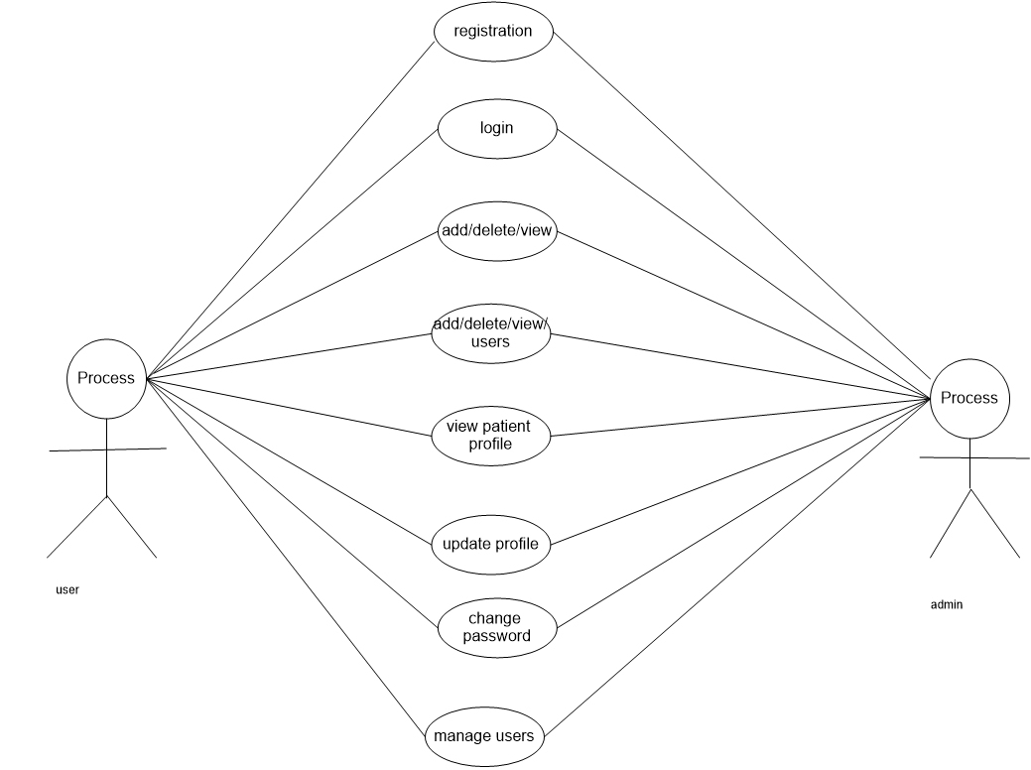

**Fig. 3.2: UML Use Case Diagram**

### 3.1.2.2 Non Functional Requirements

**Usability:** There is a consistency in all the modules and web pages. To ease the navigation there is a back tab to provide access to previous page. There is proper instruction on each page.

**Reliability:** Each data record is stored on a well-built efficient database schema. There is no risk of data loss. The internal evaluation of data is well coded.

**Supportability:** The system is well built to support any machine. Maintainability of the system is easy.

**Performance:** In order to ease the accessibility, the types of expenses/incomes are categorized along with an option to name on the own. Throughput of the system is increased due to light weight database support.

**Availability:** The system is available all the time at anywhere, no time and location constraint.

**Performance Requirements:** Application requires working system with the specified software and hardware requirements.

**Maintainability:** Maintenance is easy and economical.

**Portability:** This system can be run on any operating system including Windows, Linux and Mac.

**Security Requirements:** Application requires user to login with his mail credentials as specified in code. Only the administrator should be able to maintain the users’ accounts such as creating new users and deleting the existing users’ accounts

**Database:** Integrity should be maintained and all the constraints should be satisfied.

### 3.1.3 Data Model Requirements

The data model [4]-[6] requirements of the proposed online finance management system is shown in the Figure 3.3.

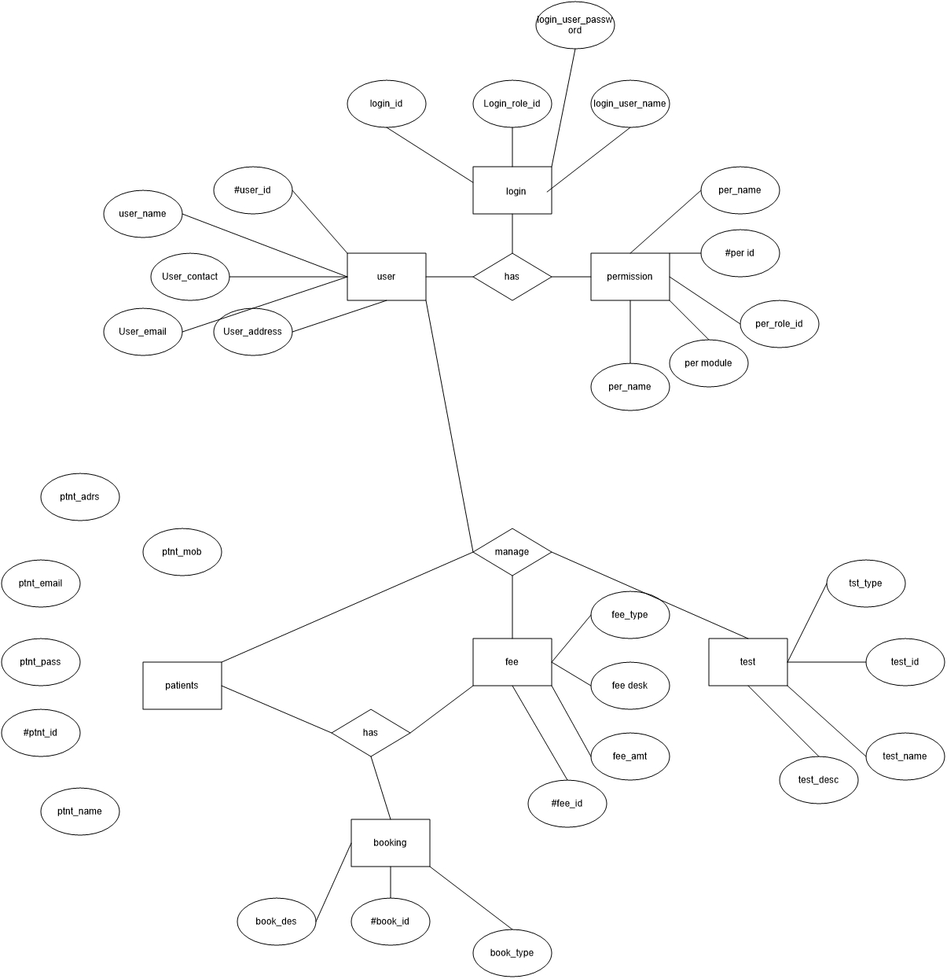

**Figure 3.3 Data model of the proposed system**

The entity relationship diagram and data model is based on the perception of real world that consists of a collection of objects called entities, and of relationship among these  
entities. The data model of the proposed system is shown in the Figure 3.3. Based on the metadata requirements, the database schema is shown in the following Figure 3.4.  
Requirements analysis used the process of understanding of the user needs and expectations from the proposed system or application. Requirements are well defined of how the proposed system should behave. The software requirement  
analysis process also covered the complex task of eliciting and documenting the requirements of all these users, modeling and analyzing these requirements and documenting them as a basis for system design.

## 3.2 System Design

### 3.2.1 Context Diagram

The Context Diagram shows the system under consideration as a single high-levelprocess and then shows the relationship that the system has with other externalentities.

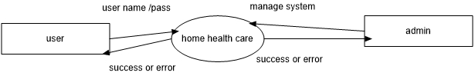

**Figure 3.5 Context diagram** **of PFMS**

### 3.2.2 Level – 1 Dataflow Diagram

Level 1 DFDs are still a general overview, but they go into more detail than a context diagram. In a level 1 data flow diagram, the single process node from the context diagram is broken down into sub processes. As these processes are added, the diagram will need additional data flows and data stores to link them together. The figure for level 1 data flow diagram is given below:

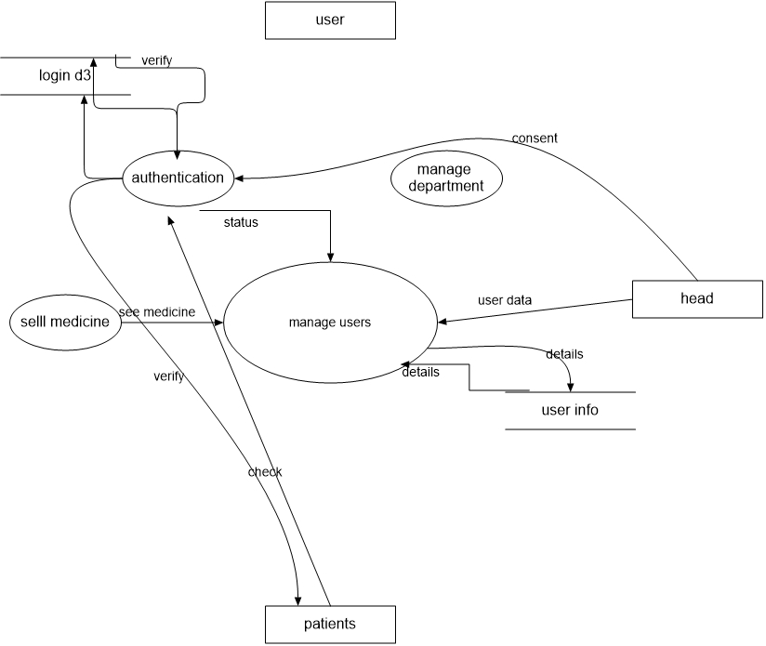

**Figure 3.6 Level-1 DFD for PFMS**

### 3.2.3 Level – 2 Dataflow Diagram

In the level 2 data flow diagram, the process is further decomposed into sub processes and hence called level 2 data flow diagram.

# dfd2.jpg

**Fig. 3.7 Level-2 DFD for System**

# CHAPTER 4

# IMPLEMENTATION

## 4.1 Introduction

Implementation is an activity that is contained throughout the development phase. It is the process of bringing designed system into operational use. The system is tested first and then turned into working system. Every task identified in the design specification are carried out in this phase.

A successful implementation of the project is a crucial phase of development life cycle and following are the steps involved in the implementation of the project:

* Test information system with data.
* Detection and correction of errors.
* Make necessary information changes in the system.
* Check information with the existing system
* Installment of hardware and software.

## 4.2 Front End Tools

**Hypertext Markup Language (HTML)**

A simple markup language used to create hypertext documents that are portable from one platform to another. HTML files are simple ASCII text files with codes embedded (indicated by markup tags) to denote formatting and hypertext links.

Many people who use HTML to create Web pages or other documents find Notepad or Notepad++ a useful tool for writing in HTML. Because Notepad supports only very basic formatting, you cannot accidentally save special formatting in documents that need to remain pure text. This is especially useful when creating HTML documents for a Web page because special characters or other formatting may not appear in your published Web page or may even cause errors.

**JavaScript**

JavaScript is an object-oriented scripting language used to enable programmatic access to objects within both the client application and other applications. It is primarily used in the form of client-side JavaScript, implemented as an integrated component of the browser, allowing the development of enhanced user interfaces and dynamic websites.

**Cascading Style Sheet (CSS)**

CSS is used to describe the presentation semantics (i.e. the look and formatting) of a document written in a markup language. It is designed primarily to enable the separation of document content (written in HTML or a similar markup language) from document presentation, including elements such as the layout, colors, and fonts.

**JQuery**

JQuery is fast and feature rich JavaScript library that makes the traversal of HTML document and manipulation, event handling, animation and Ajax interactions, simple for rapid web development. JQuery simplifies a lot of the complicated things from JavaScript, like AJAX calls and DOM manipulation but it takes a lot of common tasks that requires many line of JavaScript codes to accomplish and wraps them into methods that you can call with a single line of code.

**Bootstrap**

Bootstrap is used for making our web design interactive and responsive. It is a technique of loading a program into a computer by means of a few initial instructions which enable the introduction of the rest of the program from an input device. It is a free and open source front end web framework for designing websites and web applications.

## 4.3 Back End Tools

**PHP**

PHP code may be embedded into html or html5 markup, or it can be used in combination with various web template systems, web content management systems, and web frameworks. PHP code is usually processed by a PHP interpreter implemented as a module in the web server or as a Common Gateway Interface (CGI) executable. The web server software combines the results of the interpreted and executed PHP code, which may be any type of data, including images, with the generated web page. PHP code may also be executed with a command-line interface (CLI) and can be used to implement standalone graphical applications.

The standard PHP interpreter, powered by the Zend engine, is free software released under the PHP license. PHP has been widely ported and can be deployed on most web servers on almost every operating system and platform, free of charge. The PHP language evolved without a written formal specification or standard until 2014, leaving the canonical PHP interpreter as a de facto standard. Since 2014 work has gone on to create a formal PHP specification. PHP started out as a small open source project that evolved as more and more people found out how useful it was. Rasmus Lerdorf unleashed the first version of PHP way back in 1994.

1. PHP is a recursive acronym for “PHP: hypertext preprocessor”.
2. PHP is a server side scripting language that is embedded in html. It is used to manage dynamic content, databases, session tracking, even build entire e-commerce sites.
3. It is integrated with a number of popular databases, including MYSQL, Oracle, and Sybase, Informix, and Microsoft SQL server.

* **LARAVEL Framework**

Laravel is a web application framework written in PHP which is more secure and easy PHP framework. The most beautiful part of it is free and open source. The application developed in Laravel follows MVC platform which is Model-View-Controller. Licensed under the terms of MIT License. The source code of laravel is hosted on Github.

Definition:- Laravel is an open-source PHP framework which is based on MVC pattern. Laravel is robust and easy to learn. It is targeted for those programmers who need a medium to high level and pleasing toolkit to build full-featured web applications.

Database Model:- Database model of Laravel is Object Oriented.

Programming Paradigm :-Laravel is Object Oriented Event Driven Functional.

Routing:- Explicit Routing.

Built-in Modules:- The build in modules allow programmers to divide a project into small modules. Also, the models can be reused across various projects.

HTTPS Support:- Laravel preserves the data transmission secure by adding https:// protocol before the URL automatically. Laravel allows developers to establish custom HTTPs routes. Developers also have the choice to build a specific URL for every HTTPS route.

Developers always focus on faster and easier development with lot of security and features. Laravel makes it easier in such situation. Laravel is so popular framework in the market.

**PostgreSQL**

Relational database management systems (RDBMS) are extremely popular and are quite an integral part of application development. Many different RDBMS exist, for example, MySQL, PostgreSQL, IBM DB2, Oracle 11g and so on. Such an RDBMS PostgreSQL is a powerful, open source object-relational database system with over 30 years of active development that has earned it a strong reputation for reliability, feature robustness, and performance

# CHAPTER 5

# TESTING

## 5.1 Introduction to Testing

Testing can be stated as the process of validating and verifying that an application can works as expected, satisfies the need of stakeholders and meets the requirements that guided its design. It is a process that helps to identify the correctness, completeness and quality of developed computer software. It ensures that the developed parts conform to the user requirements. Software testing is more than just debugging. The purpose of testing can be quality assurance, verification and validation, or reliability estimation. During the development of the project following testing process were followed.

Testing is an integral part of the software development process. It is performed at each stage of the SDLC. It ensures that the developed parts confirm to the user requirements. It helps to find out whether an input given to the system is well processed or not and output meets the specified objective of the system. It mainly ensures that the system performs as planned. The testing of system was carried out step by step. Testing is performed at key points that are crucial for the working of a system. In hardware system testing is done for individual components that are used to make up a system. In other word testing is a process of Validation and Verification. Validation is the process of checking if the system will meet the customer’s actual needs, whereas Verification is concerned whether the system is well-engineered and error free.

Various types of testing procedures were performed in order to check the working mechanism and correctness of the system. Some of the types of testing that we did attempt are described below:

### 5.1.1 Unit Testing

The purpose of unit testing in this project is to check that as individual parts of the system are functioning as expected or not. We have tested each module of this system in order to check the correctness of the output. Firstly, we found many errors and then it was resolved stepwise. For this testing, we test for login section by registering new users and providing access to use the system. We added users, in the database. Hence, unit testing is done.

### 5.1.2 Integration Testing

The Integration testing part of a testing methodology is the testing of the different modules/components that have been successfully unit tested when integrated together to perform specific tasks and activities. The test is often done on both the interfaces between the components and the larger structure being constructed, if its quality property cannot be assessed from its components. After integrating the requirements we tested it, it was fine and satisfactory.

**5.1.3 System Testing**

Prior to the actual implementation of the system it had to be tested comprehensively and every possible error uncovered. Since it is not possible to test the system exhaustively, the black box testing method was used for system testing. The black box testing usually demonstrates that software functions are operational, that the input is properly accepted and the output is correctly produced; and that integrity of external information (database) is maintained.

**5.1.4 Module Testing**

A module is composed of various programs related to that module. Module testing is done to check the module functionality and interaction between units within a module.

**6.1.5 Acceptance Testing**

Acceptance testing is done after implementation to check if the system runs successfully in the users environment.

## 5.2 Result Analysis

“Home Health Care System” is a web based application which is still under development and even the functioning part are in various pieces. Various results have been tested for validation and verification process.

### 5.2.1 Validation

**Email Validation:**

When email address is submitted by user, it must follow the following expression otherwise it gets the error message.

[a-zA-Z0-9][+@[a-zA-Z0-9]+.com](mailto:+@[a-zA-Z0-9]+.com)

For example, [bist@amar.com](mailto:bist@amar.com) is a valid email address but [bist@amar@nepal.com](mailto:bist@amar@nepal.com) is an invalid email address.

**Password:**

For the new user (patients) during registration, password field must be at least 8 characters otherwise system displays “Password too short! At least 8 letters”.

Test 1:

Input: password

Output: System performs the function smoothly.

Test 2:

Input: pass

Output: Password too short! At least 8 letters.

Test 1:

Input: Password

Output: Input is accepted.

Test 2:

Input:

Output: This field is required.

# CHAPTER 6

# CONCLUSION AND FUTURE WORK

## 6.1 Conclusion

From this project, we are able to manage and keep tracking the daily  
expenses as well as income. While making this project, we gained a lot of  
experience of working as a team. We discovered various predicted and  
unpredicted problems and we enjoyed a lot solving them as a team. We  
adopted things like video tutorials, text tutorials, internet and learning  
materials to make our project complete. Furthermore, now we know much  
more about the MTV framework (laravel), php language and the SQLite query.

People always want to find the way to make their life easy and comfortable. Currently,  
we depend on the web pages much for everything such as- searching, purchase desire  
goods etc as there are many web applications depend on various requirements. Today’s  
web applications are rich internet applications and developers are much concerned about  
applications security issues while they are developing their products. A user friendly  
system becomes popular rapidly and thus benefits both the system developer and its  
users. So we decided to develop this web application which will be user friendly, highly  
security protected with their financial activities and personal information and everybody  
will be able to manage their personal finance daily with ease via internet.

Finally we try to work about the online web based system and develop the   
personal financial management system.

## 6.2 Future Scope

So far we are confident that we have done this web application successfully, but we have a plan to make this application more efficient, so we think about some features that can be added for future development, ideas are followings-

* Provide backup and recovery of data.
* Provide better user interface for user.
* We will try to make Mobile version of our project so that everybody can manage their personal financial account using mobile.
* The software will be improved further with enhanced functionality so that people  
  of all languages can use it.

# REFERENCES

[1] Alan Dennis, Barbara Haley Wixom and Roberta M. Roth, *System Analysis And Design*, Fifth Edition ed., Beth Lang Golub, Ed.: Don Fowley, 2012.

[2] Ian Sommerville, *Software Engineering*, 10th ed.: Pearson Education, 2016.

[3] Rajeev Chopra, *Software Project Management*., 2009.

[4] Harrington, J. L. (2010). *Relational Database Design Clearly Explained.* John Wiley.

[5] *Database Design*. (n.d.). Retrieved October 02, 2021, from <http://en.wikipedia.org/wiki/Database_design>

[6] *Use case diagram concept*. (n.d.). Retrieved october 06, 2021, from <http://en.wikipedia.org/wiki/Use_case>

[7] *Software testing*. (n.d.). Retrieved September 07, 2021, from <http://en.wikipedia.org/wiki/Software>

**Appendices**

**Operational snapshots of home health care system**

1. **home page:**

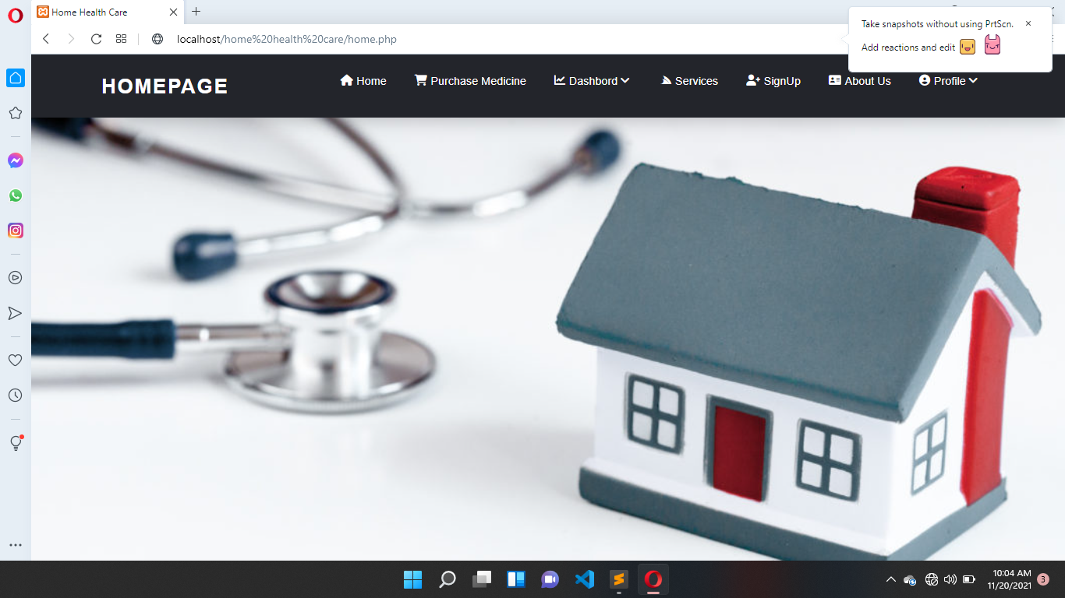

1. **Login Page:**

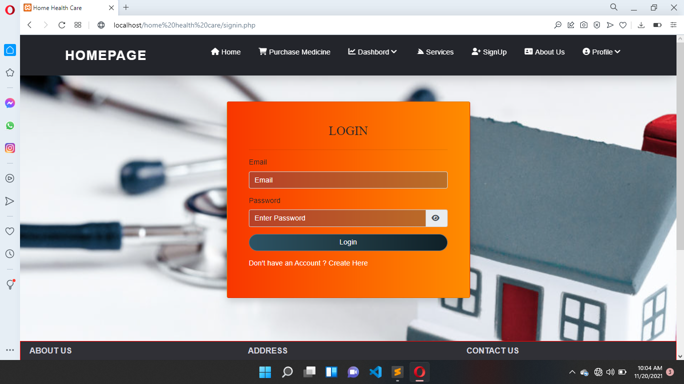

1. **Signup page:**

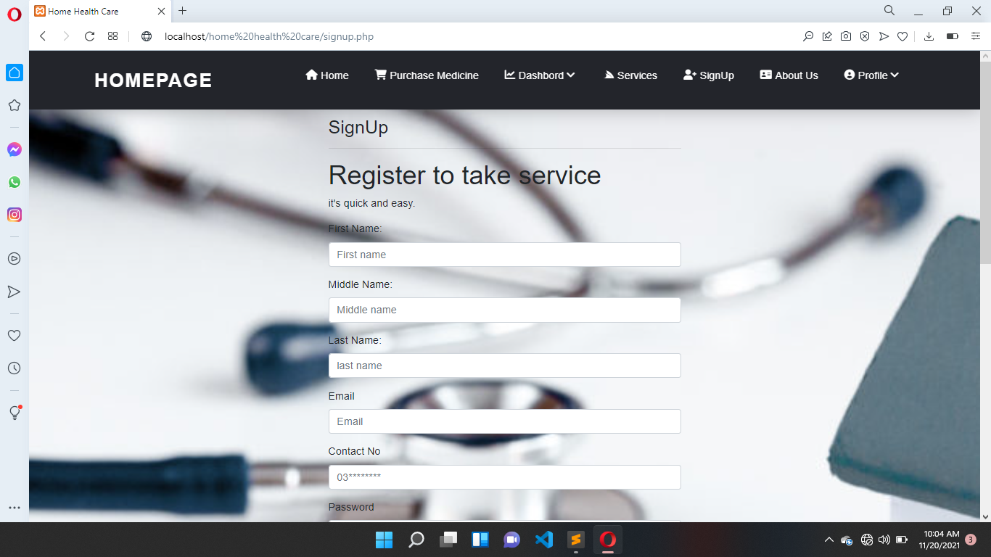

1. **Our service page:**

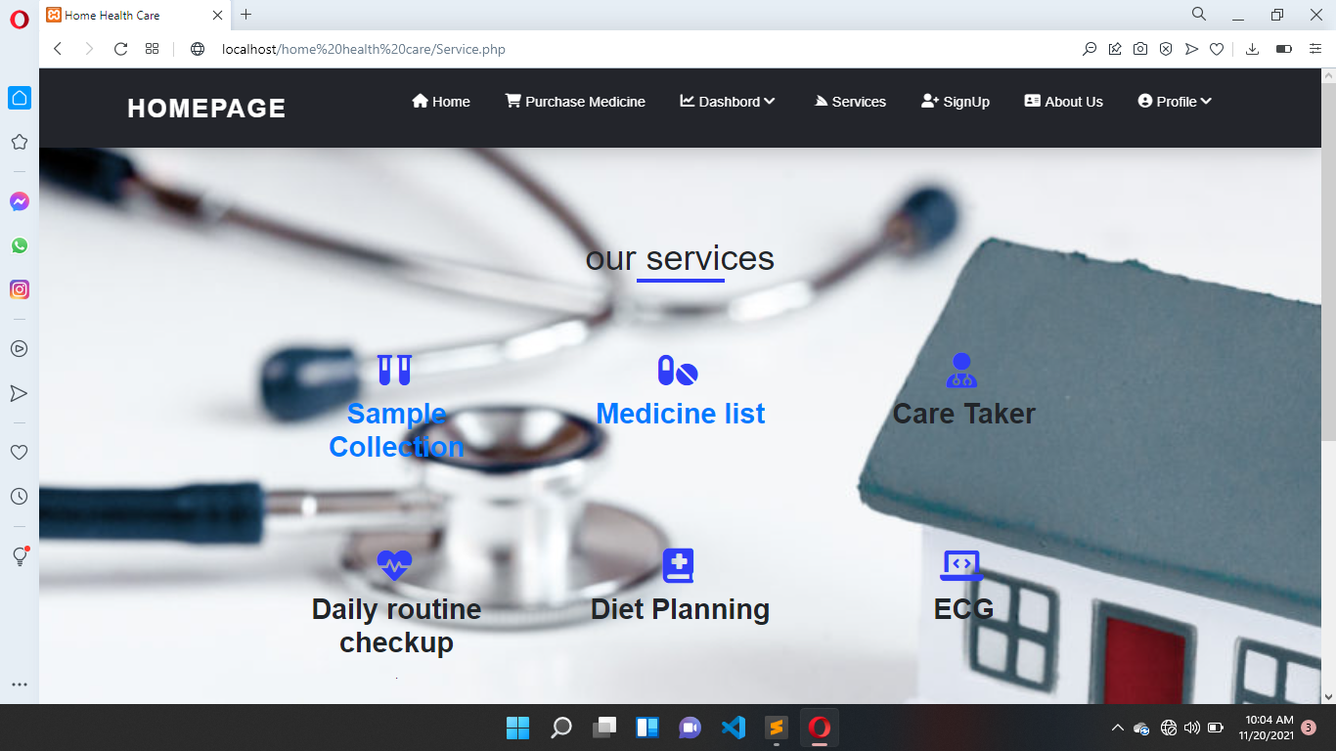

1. **Buy medicine:**

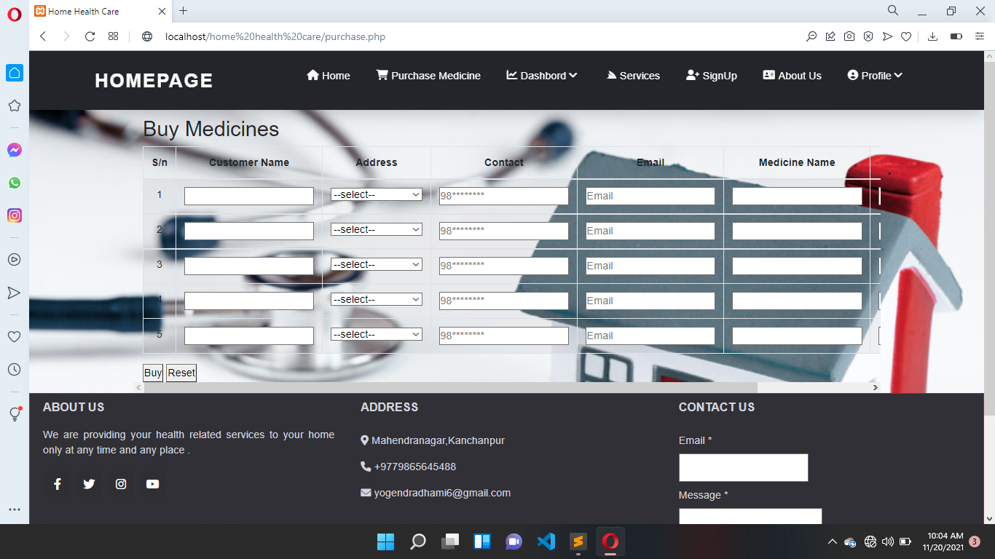

1. **Medicine list and price:**

